Project 4

**Hidden Message c:**

1027795314451781443748475386257882516

**Factors of**

**1029059010426758802790503300595323911 (N) Found using Wolfram Alpha which are P and Q:**

216273774599027 and

4758131272895389067293

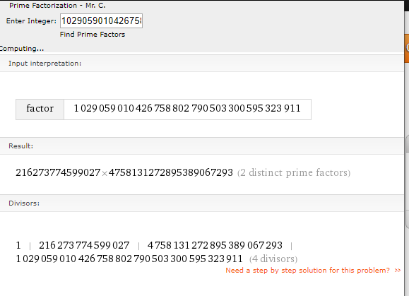

**Phi value found using Wolfram calculator and finding the product of (P-1)(Q-1):**

1029059010426754044659014131431657592

**e value:**

2287529

**GCD using Phi and e using the GCD program that was provided:**

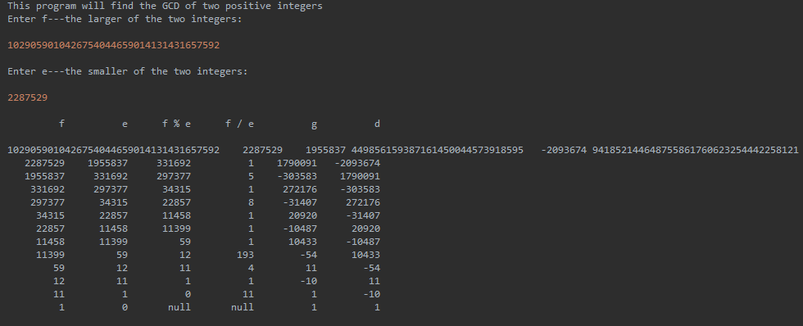

d = 941852144648755861760623254442258121

**Plain text message using ModExp:**

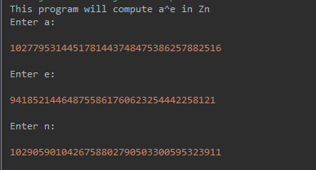

52807870857374797201687770877083

**After using decoding program:**

Please enter the encoded message:

52807870857374797201687770877083

The decoded message is:

Something clever